**Online Shopping Application**

1. **Database Design**

Based on the project requirements, the following tables are proposed:

**1. Users**

- UserID (Primary Key)

- Name

- Email (Unique)

- Password

- Address

- Phone

- Role (User/Admin)

**2. Products**

- ProductID (Primary Key)

- Name

- Description

- Price

- Stock

- CategoryID (Foreign Key)

- ImageURL

**3. Categories**

- CategoryID (Primary Key)

- CategoryName

**4. Orders**

- OrderID (Primary Key)

- UserID (Foreign Key)

- OrderDate

- TotalAmount

- Status (Pending/Shipped/Delivered)

**5. OrderDetails**

- OrderDetailID (Primary Key)

- OrderID (Foreign Key)

- ProductID (Foreign Key)

- Quantity

- Subtotal

**6. Cart**

- CartID (Primary Key)

- UserID (Foreign Key)

- ProductID (Foreign Key)

- Quantity

**2. ER Diagram:**

The ER diagram visually represents the relationships between the entities .

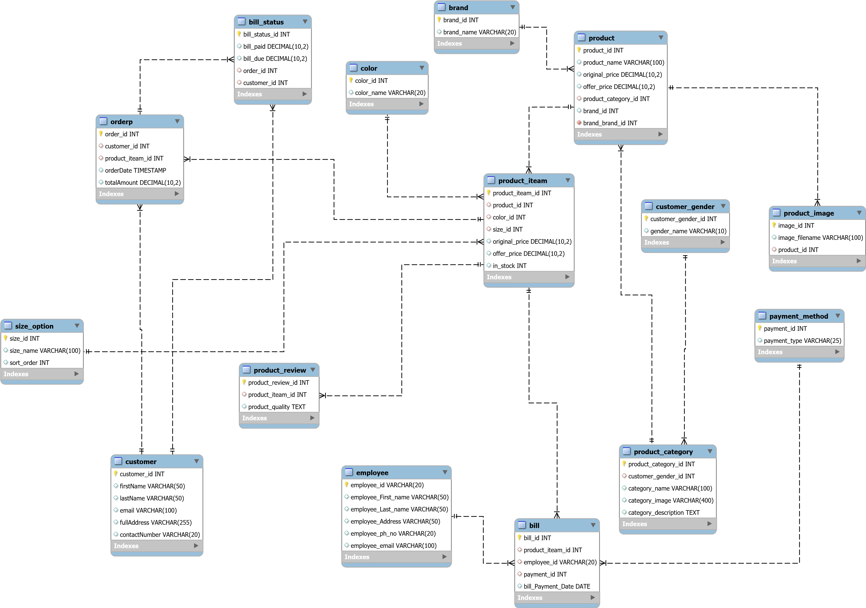The main entities include Users, Products, Categories, Orders, OrderDetails, Cart etc. Attributes and primary keys are defined for each’

# Normalization

Normalization ensures that the database is structured efficiently:

* 1. First Normal Form (1NF)
     + Ensure that all attributes contain atomic values.
     + Example: Splitting full names into FirstName and LastName.
  2. Second Normal Form (2NF)
     + Remove partial dependencies; all non-key attributes are dependent on the entire primary key.
     + Example: Separate order details into an OrderDetails table to remove duplication.
  3. Third Normal Form (3NF)
     + Remove transitive dependencies; non-key attributes should not depend on other non-key attributes.

- Example: Store categories in a separate table to eliminate redundant data in the Products table.